**Step Up to Spanish A Level (2)**

**How to learn Spanish?**

When learning a language, the saying that “practice makes perfect” is very appropriate. You develop a higher level of comprehension (listening and reading) if you expose yourself to the language every day. The simplest of actions can help you develop vocabulary e.g. putting on Spanish subtitles on your favourite programme, changing the language settings on your email account to Spanish, etc.

This second set of activities focuses on the kind of things you can do regularly to develop these habits and to develop a great level of Spanish.

**Transition Activities:**

**Preparing for A Level Spanish**

You are to be set a further three tasks. These are linked to skills you will need at Spanish A Level. We will focus on:

1. Sentence structure /grammatical accuracy
2. Cultural awareness *(- exposure to Spanish language music and culture)*
3. Vocabulary development + conceptual awareness (- *the how and why of things*)

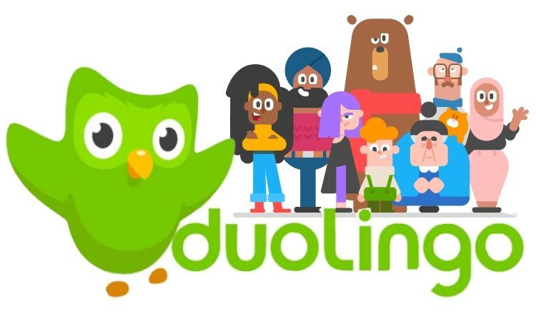

**Task 1 – Sentence structure / Grammar**

Complete a story on Duolingo every day

<https://stories.duolingo.com/>

Duolingo Stories is a way to practice your listening and reading comprehension using bite-sized interactive stories. By completing one every day you will get to revise and improve lots of language you have been learning so far in Spanish. Each task takes around 5-10 minutes.

You can complete Duolingo stories on the internet or on a mobile app.

When you first register (select the free account), you will take a quick test which will help the app to tailor the work set to your level.

**Task 2 – Cultural awareness**

As part of the speaking exam at A level, you will learn how to analyse texts and to infer meaning. Sometimes people imply meaning rather than saying things directly and when you understand the culture, this can further help to improve your comprehension.

We are going to look at a song by a band called Bomba Estéreo. Complete the following tasks:

1. Go online and find out as much as you can about Bomba Estéreo e.g. Where are they from? How long have they been going? Have they ever performed in the UK?
2. Watch the video for the song “*Soy yo*” (link on next page). Does the video help you to understand what the message of the song might be? If so, what do you think the message is? The message is implied.

[](https://www.google.com/url?sa=i&url=http%3A%2F%2Fwww.fashionradicals.com%2Fbomba-estereo-y-camo-amor-filial%2Fbomba-estereo-1%2F&psig=AOvVaw0vWUgr_Tddvl2OQxMVRg78&ust=1591210717575000&source=images&cd=vfe&ved=0CAIQjRxqFwoTCPia6Ijo4-kCFQAAAAAdAAAAABAU)[](https://www.google.com/url?sa=i&url=http%3A%2F%2Fhighlineballroom.com%2Fshow%2F2015%2F07%2F24%2Fbomba-estereo%2F&psig=AOvVaw30dFZPB5XBgPPJrZNFknFw&ust=1582660064584000&source=images&cd=vfe&ved=0CAIQjRxqFwoTCPDHoKv66ucCFQAAAAAdAAAAABAD)[](https://www.youtube.com/embed/bxWxXncl53U?feature=oembed)

Or click on the link - <https://www.youtube.com/watch?v=bxWxXncl53U>



|  |  |
| --- | --- |
| Yo caí, me paré, caminé, me subí Me fui contra la corriente y también me perdí Fracasé, me encontré, lo viví y aprendí Cuando más te pegas fuerte, más profundo es el beat  Sigo bailando y escribiendo mis letras Sigo cantando con las puertas abiertas Atravesando por todas estas tierras Y no hay que viajar tanto pa' encontrar la respuesta  Y no te preocupes si no te aprueban  Cuando te critiquen, tú solo di  Soy yo  Soy yo  Soy yo  Soy, soy, soy, soy, soy, soy, soy Soy yo  Yo, yo, yo, yo, yo, yo, yo  Sigo caminando y sigo riendo  Hago lo que quiero y muero en el intento  A nadie le importa lo que estoy haciendo  Lo único que importa es lo que está por dentro  A mí me gusta estar en la arena Bañarme en el mar sin razón, sin problema  Estar sentada sin hacer nada  Mirando de lejos y estar relajada | Y no te preocupes si no te aprueban  Cuando te critiquen, tú solo di  Soy yo  Soy yo  Soy yo  Soy, soy, soy, soy, soy, soy, soy Soy yo  Yo, yo, yo, yo, yo, yo, yo  Soy así, soy así, soy así Relaja'a Y tú ni me conoces a mí Bien relaja'a  Soy así, soy así, soy así Relaja'a Y tú ni me conoces a mí Bien relaja'a You know what I mean You know what I mean  Y no te preocupes si no te aprueban  Cuando te critiquen, tú solo di  Soy yo  Soy yo  Soy yo  Soy, soy, soy, soy, soy, soy, soy Soy yo  Yo, yo, yo, yo, yo, yo, yo |

1. Have a look through the lyrics for the song + highlight any sentences that help explain what the song is about.
2. Now read through an article that appears in an online newspaper from Colombia + answer a couple of questions.

# “Soy Yo”, el video de Bomba Estéreo

Del álbum “Amanecer” nos llega la canción “Soy Yo” con un clip protagonizado por una joven heroína que no se deja intimidar por nada.

“No te preocupes si no te aprueban, cuando te critiquen tú solo di: ‘Soy yo’”, dice la canción. “*El mensaje es el de no dejarse afectar por las críticas de otras personas y que la aceptación de uno mismo es esencial. El video se enfoca en los niños, haciendo referencia al acoso escolar que ocurre en los colegios*”, añadió la cantante de Bomba Estéreo.

1. Highlight parts of the text that support your view on what the song is about. Also, what is the singer from the band saying in her quote?

**Task 3 – Vocabulary development + conceptual development**

When covering all the General Topic Areas for A level Spanish you will encounter a wide range of vocabulary. Knowledge of a wide range of vocabulary is a key feature of high attainers at Spanish A level. This is a skill that you can develop independently by having regular contact with the language. An easy way of doing this is checking headline news and working out meanings. At the same time this helps you to develop greater awareness of issues and concepts and to develop your own views which is another important element of A level Spanish.

In Task 3 you will look at news and current affairs websites and work out what some of the articles are discussing. This will help you to develop your cultural awareness of what is happening in Spain and other Spanish-speaking communities.

It is generally best to start with international news as you will be more familiar with what is going on. Use the following two websites:

[](https://www.eldiario.es/)

<https://www.eldiario.es/>

[](https://www.huffingtonpost.es/internacional/)

<https://www.huffingtonpost.es/internacional/>

Go to one of these websites and select a headline. To work out what the article is discussing you may want to use an online dictionary. Use the following: [www.wordreference.com](http://www.wordreference.com) – this is used by professional translators and is one of the best. I also recommend these other two: [SpanishDict | English to Spanish Translation, Dictionary, Translator](https://www.spanishdict.com/)

and [Reverso Context | Translation in context from Spanish to English](https://context.reverso.net/translation/spanish-english/) that allows you to see the translations in context.

Once you have selected your headline, pick out the key words, look up ones you do not know and produce a summary in English.

[](https://www.eldiario.es/)

**Example 1:**

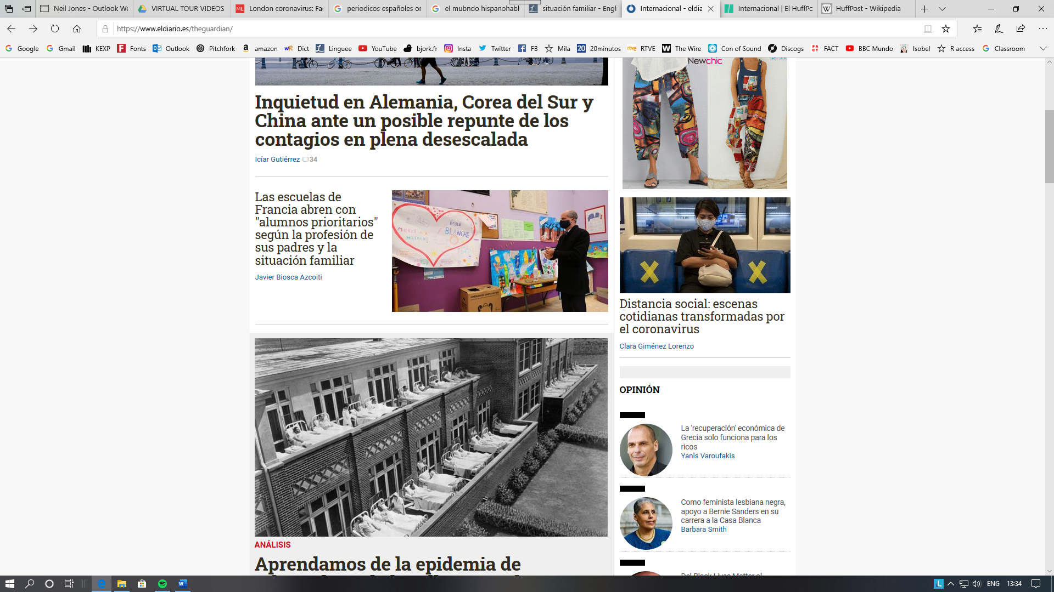**This is taken from the *eldiario* website:**

*The headline is talking about schools in France reopening (after the coronavirus lockdown), but this is for priority students depending on what type of work their parents do and their family situation.*

**Example 2:**

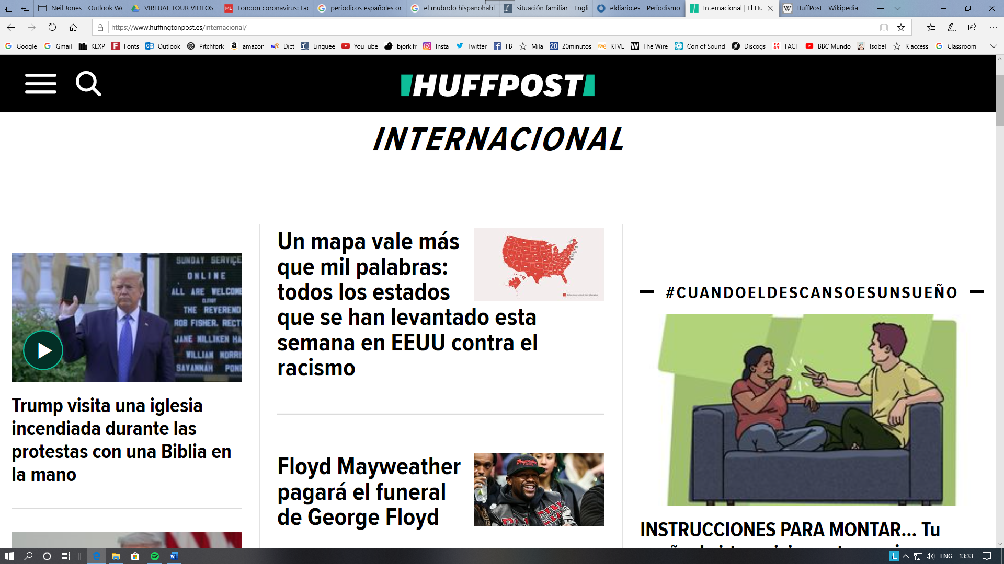**This is taken from the *huffingtonpost.es* website:**

[](https://www.huffingtonpost.es/internacional/)

*The headline talks about Trump’s visit to a church that was set on fire during protests with a bible in hand.*

* **Do this at least once a week and keep a record of the new vocabulary.**
* **Learn the new words as you go along.**



[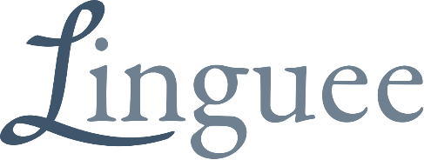](https://www.google.com/url?sa=i&url=https%3A%2F%2Fen.wikipedia.org%2Fwiki%2FLinguee&psig=AOvVaw1uYkZR_Q3AR2NRVk9RZzee&ust=1591210203775000&source=images&cd=vfe&ved=0CAIQjRxqFwoTCLCy94nm4-kCFQAAAAAdAAAAABAD)**Support materials**

The best online translator is [www.wordreference.com](http://www.wordreference.com)

Another very useful website is [www.linguee.com/spanish-english](http://www.linguee.com/spanish-english)

Avoid Google Translate. This is not a very accurate tool and is best avoided unless it is for single words. Use WordReference and Linguee instead. The above websites also exist as free apps for your phone.

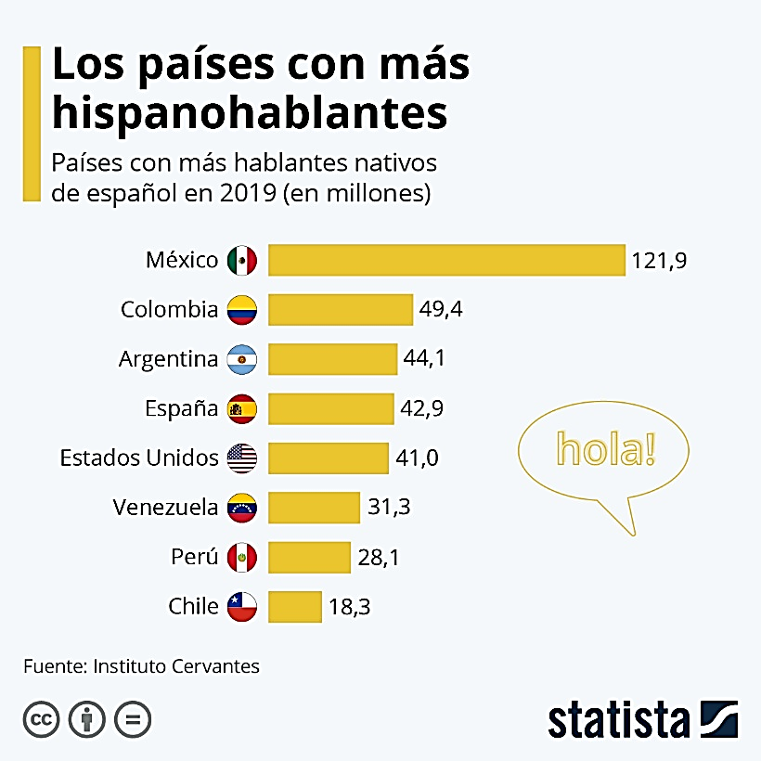

[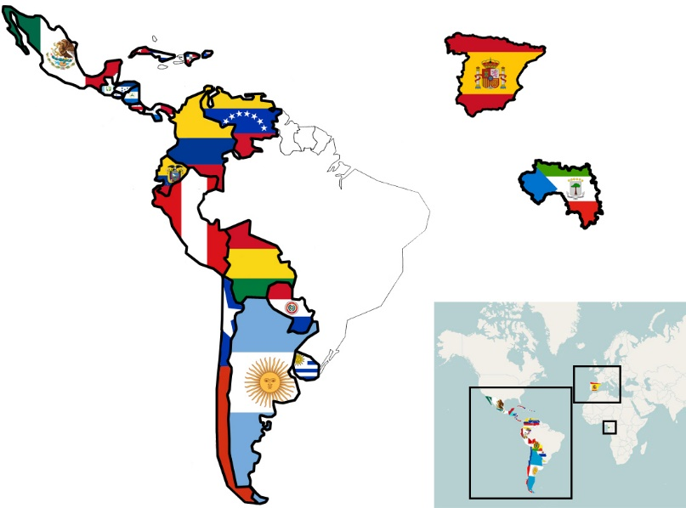](https://www.google.com/url?sa=i&url=https%3A%2F%2Fwww.thinglink.com%2Fscene%2F679447912463204353&psig=AOvVaw13VIZrm3wZUFThAkkx0Ve2&ust=1591186413787000&source=images&cd=vfe&ved=0CAIQjRxqFwoTCLDVuLmN4-kCFQAAAAAdAAAAABAl)