**How to prepare for Spanish at A Level**

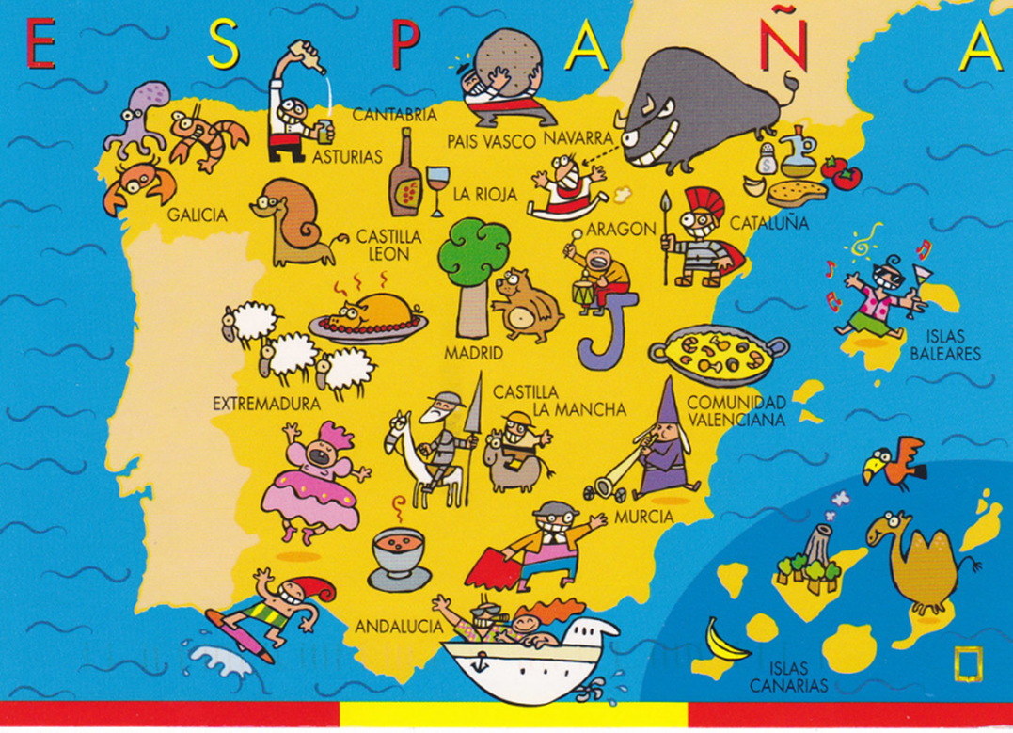

You have a few weeks in which to really prepare for your A Level in Spanish. The leap from GCSE to A Level is significant. This booklet contains links to a huge range of media, most of which is available for free online as well as tasks to complete before the start of term. In order to keep pace, it is vital that you work through the tasks. Little and often…

**Description of task:**

We expect you to do a little research into Spanish language and culture each week over the summer. Fill in your learning log with details of what you have done each week to keep up your Spanish language skills.

1. Listen to Spanish-speaking radio / Spanish-speaking music charts to discover some Spanish-speaking groups / singers: <http://www.rtve.es/radio/radio3/> <http://www.cadenadigital.com/>

<https://los40.com/>

2. Summer headlines - have a look at some of the following newspaper and TV sites and pick out 3 that you find interesting or funny. <https://www.bbc.com/mundo> <https://www.20minutos.es/> [http://www.elpais.com/](http://www.elpais.com/%20) , <https://lavanguardia.com>. You do not have to read the paper cover to cover, just scan the headlines and pick out ONE article that grabs your attention.

3. Research some Spanish celebrities using the internet. Find out some information about people who are regularly in the Spanish papers. <https://www.elle.com/es/> <https://www.diezminutos.es/>

4. Improve your vocabulary by doing a little bit each day on Quizlet (search for AS Level Spanish).

<https://quizlet.com/246864749/aqa-a-level-spanish-flash-cards/>

<https://quizlet.com/gb/273215228/aqa-a-level-spanish-verbs-flash-cards/>

<https://quizlet.com/gb/273214732/aqa-a-level-spanish-essay-terminology-flash-cards/>

5. Listen to some of the songs and read the lyrics as you go. Sing along to your favourite.

Rosalía <https://www.youtube.com/channel/UCQt9awGIFZeldFsATZNeJag>

J Balvin <https://www.youtube.com/channel/UCt-k6JwNWHMXDBGm9IYHdsg>

Kevin y Karla <https://www.youtube.com/user/kvnvasquez>

6. MOVIES

Choose one of the following movies to watch over the summer:

* Volver (Pedro Almodóvar, 2006)
* Ocho Apellidos Vascos (Emilio Martínez- Lázaro, 2014)
* El Laberinto del Fauno (Guillermo del Toro, 2006)
* María llena eres de gracia (Joshua Marston, 2004)
* Abel (Diego Luna, 2010
* Las 13 Rosas (Emilio Martínez-Lázaro, 2007)

Remember, you are not limited to using just the above websites. Anything is suitable as long as it helps you practise your Spanish.

**Desired outcome:**

Developing resilience for independent work and research, keeping up to date with relevant Hispanic culture and developing a greater interest in Hispanic culture.

**Form of assessment to ensure that the work has been completed:**

Return the completed learning log and submit to Sra. Charlton on your first lesson back. You will be quizzed on what you have read/watched/listened to and will be asked to provide opinions and facts about what you have done.

**Useful Resources**

**Watch…**

TELEVISION

• If you have Netflix or Amazon Prime, try searching for “Spanish language films” or “Spanish

language TV”. Many English language films/programmes also have a Spanish audio or

subtitle option

• <http://www.bbc.co.uk/languages/spanish/tv/>

The BBC website has some useful links to Spanish TV programmes online and tips for how to get the most out of it.

• <https://www.rtve.es/alacarta/>

A range of programmes available to view online from the Spanish equivalent (roughly) of the BBC

• <https://www.telecinco.es/>

One of the most popular TV channels in Spain. Not all of the content is available to watch outside of Spain but there are lots of great programmes on there which are available online.

• <http://www.telemadrid.es/> Videos from Madrid’s own regional TV channel

• [www.rtve.es/noticias](http://www.rtve.es/noticias) Click on the Telediario for a 4-minute version of the daily news

FILM

As well as those available with subscriptions like Netflix, there are also a range of Spanish

films available to rent, buy or view for free on YouTube, or of course you can order a DVD

online. Here are some film suggestions you may like to try:

o Ocho apellidos vascos

o Maria, llena eres de gracia

o Volver

o Abel

o Las 13 rosas

o Diarios de motocicleta

o La lengua de las mariposas

**o** El Laberinto del Fauno (Pan’s Labyrinth)

**Listen…**

RADIO

Listening to Spanish radio is a great way to expose yourself to more Spanish easily. Have it

on in the background while you are doing something else!

o Radio Nacional de España (<https://www.radio.net/s/rneradionacional>)

o Cadena SER (<https://cadenaser.com/>)

o Europa FM (<https://www.radio.net/s/europafm>)

o <https://tunein.com/radio/Spain-r100416/>

A comprehensive list of radio channels in Spain available online

• <https://blog.lingoda.com/en/10-radio-stations-to-help-you-learn-spanish>

This blog post contains links to 10 Spanish-speaking radio stations available online. This includes radio stations from Latin American countries as well as from Spain.

MUSIC

Look up current Spanish artists in the Spanish music charts and listen to some of their music

on YouTube. The suggested videos down the side or underneath are often a good way of

discovering new music – and don’t forget to ask others for their recommendations.

• [www.lyricstraining.com](http://www.lyricstraining.com)

Use this website to listen to Spanish music while improving your listening skills. Listen to a song with the accompanying YouTube video and fill in the missing words in the lyrics underneath. There are 4 difficulty levels and two settings – multiple choice mode or typing mode

* Spotify : follow the Spanish department’s account , KESpanish, for lists of songs organised by grammatical or vocabulary topics.

**Read…**

NEWSPAPERS AND MAGAZINES

• <https://www.bbc.com/mundo>

News stories from around the world in Spanish covering a range of topics

• <http://www.elpais.com/>

Like many Spanish newspapers, El País is available to read online. You don’t have to read the full paper cover to cover, just try to find one article that grabs your attention.

• <https://www.20minutos.es/>

This is a more light-hearted newspaper which covers gossip as well as global news stories. There is also a video section <https://www.20minutos.es/videos/>

• <https://www.w3newspapers.com/spain/>

This site contains links to a number of Spanishlanguage newspapers available to read online.

• <https://www.abc.es/familia/padres-hijos/jovenes/>

Many online news sites have a section aimed at younger readers. Look for the ‘jovenes’ section like this one.

OTHER WAYS TO READ

• Change the language on your phone to Spanish – eventually you will be reading in Spanish without even realising it (and it’s a great way to get a head-start on the technology topic)

• Set your default internet search engine to [www.google.es](http://www.google.es) instead of the English version.

• Use a different search engine such as <http://es.yahoo.com/> . Setting this as your homepage

will make you read Spanish every time you log on and it will become an easy part of your

daily routine.

• Keep your own vocabulary log. Have an entire exercise book or notebook dedicated to this

that you have with you every time you read, watch or listen to something in Spanish

• [www.twitter.com](http://www.twitter.com)

If you haven’t got a Twitter account, I would suggest signing up for one. Because of the character limit, you never have too much to read! See what interesting channels you can find to follow. Try something these to get you started.

|  |  |
| --- | --- |
|  |  |
|  |  |
|  |  |

**Surf…**

OTHER USEFUL WEBSITES

• [www.memrise.com](http://www.memrise.com) – invaluable for learning Spanish vocabulary. The site is designed in such a way that if you stick with it and use it regularly, reviewing past vocabulary items as well as learning new vocabulary, it automatically sticks in your long-term memory

• <http://wikipedia.es> Use the Spanish version of Wikipedia when researching topics. It makes

picking up the vocabulary much easier! Bear in mind though that anybody can edit Wikipedia so don’t take everything you read as fact! Still a good starting point though.

• [www.wordreference.com](http://www.wordreference.com) A really useful online dictionary. Don’t forget to use the

conjugate tool for online verb tables too

Do you want to do more?

1. Summarise, in Spanish, 2 articles (that were in Spanish!) that you have read from one of the websites/ papers above and say why they interested you. If you cannot print the article, make a note of the website. Try and make these related to one of the topics we will study (listed below).

**Aspects of Hispanic Society:** Modern and traditional values (changes in family, marriage and divorce, influence of the Catholic Church); Cyberspace (influence of the internet, risks and benefits of the internet, smart technology in our society).

**Multiculturalism in Hispanic Society:** Immigration; Racism; Integration

**Artistic Culture in the Hispanic World:** Modern Day Idols; Spanish regional identity; Cultural Heritage

1. Look out for any items in the English or Spanish media relating to topics we will study – as above so that you have points to make in a discussion and opinions to give.
2. Go onto [www.languagesonline.org.uk](http://www.languagesonline.org.uk/) . Complete 10 exercises. Each exercise takes less than 5 minutes. Note down the exercise you did and your score.

**Research Tasks**

Below are some suggested tasks to complete in preparation for studying some of the Alevel topics. Some of the tasks are aimed at gaining a greater knowledge of Spanish culture in general whereas others are directly linked to one of the modules on the A-level course.

Keep a log of all of the tasks you complete and don’t forget to record your sources (e.g.

books used, websites visited and the date).

**IMPORTANT FIGURES**

What are these people known for?

|  |  |
| --- | --- |
|  | Francisco Franco |
|  | Che Guevara |
|  | Evita Perón |
|  | Miguel de Cervantes |
|  | Clara Campoamor |
|  | Shakira |
|  | Salvador Dalí |
|  | Frida Kahlo |

LA IDENTIDAD REGIONAL EN ESPAÑA

¿Cuántas lenguas minoritarias se habla en España? _____________________________

¿Sabes qué es la merienda? _____________________________

¿Cuál es tu fiesta hispánica preferida? _____________________________

****Appendix 1 **GENERAL TIPS**

**Vocabulary:**

• When you come across a new word, try to deduce its meaning from context or from the

structure of the word.

• Does the word appear in other sentences which may help you work out the meaning?

• You are more likely to remember something you’ve worked out for yourself – try to resist rushing straight for the dictionary

• Try a monolingual Spanish dictionary first – can you work out the meaning from its definition in Spanish?

• Keep track of new vocabulary:

o Spanish/English

o Spanish/Spanish definition

o Colour-coding for masculine/feminine or adjectives/verbs

o New sheet/page for different topics

o Example sentence using the word/phrase in context

• Learn vocabulary regularly:

o Look, cover, write, check

o Find/Create a course on Memrise or Quizlet

Dictionaries:

• Familiarise yourself with the abbreviations used (e.g. adv for adverb, vi for intransitive verb

etc.) and be aware of the function of the word you are looking up

• To ensure you have found the right word, look it up the other way round (Spanish-English,

English-Spanish)

• Take note of genders of nouns and types of verbs

• WordReference is an excellent online bilingual dictionary and has a free mobile app

**Grammar:**

Familiarise yourself with grammatical terms in Spanish and English. This will help you when

learning about a new grammar point or looking up particular types of word in a dictionary.

• There are many websites available with online grammar practice – a quick Google search

will provide you with hours of independent study.

• Don’t be ashamed of completing ‘beginner level’ grammar activities – it is always good revision and can help improve your accuracy

Appendix 2

Lista de artistas españoles o latinos

GRUPOS:

El canto del loco

Taburete

Amaral

La Oreja de Van Gogh

DVCIO

Chambao

Estopa

Maldita Nerea

ARTITAS O GRUPOS LATINOAMERICANOS:

Luis Fonsi

Ricky Martin

Karol G

Shakira

Ricky Martin

Juanes

J Balvin

Maluma

Bad Bunny

Morat

Paulina Rubio

Andrés Calamaro

Greeicy

Pitbull

Don Omar

Ozuna

Daddy Yanji

Julieta Venegas

Paulo Londra

Rosalía

Alvaro Soler

C Tangana

Aitana

Lola Indigo

Don Patricio

Dani Martín

Guitarricadelafuente

Leiva

Pablo Alborán

Pol Granch

Pablo Lopez

Macaco

India Martinez

Bad Gyal

Alejandro Sanz

Beatriz Luengo

Mala Rodriguez

Zahara

Rozalén

David Bisbal

Chenoa

Malú

Natalia Lacunza

Manuel Carrasco

Vanesa Martín

Melendi

Enrique Iglesias

FOR MORE: Type in youtube: La mejor música en español 2021