**SIXTH FORM SUGGESTED READING LIST**

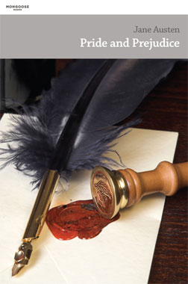[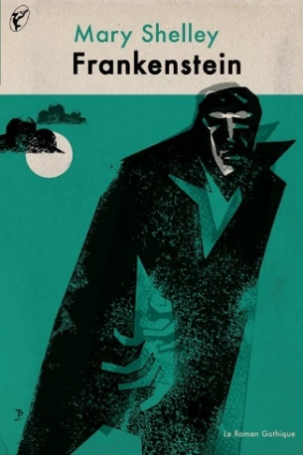](https://www.google.co.uk/url?sa=i&rct=j&q=&esrc=s&source=images&cd=&cad=rja&uact=8&ved=2ahUKEwi2nI6UgPHbAhURlxQKHY65ACoQjRx6BAgBEAU&url=http://www.printmag.com/design-culture-2/history-2/frankenstein-covers/&psig=AOvVaw1vEuAam54yV-OgpHiy6ZEd&ust=1530091230450457)**A SELECTION OF CLASSICS**

*Pride and Prejudice / Emma*, Jane Austen

*Wuthering Heights*, Emily Brontë

*Jane Eyre*, Charlotte Brontë

*A Tale of Two Cities /Great Expectations*, Charles Dickens

*Tess of The D'Urbervilles / Far From the Madding Crowd*,

Thomas Hardy

*The Woman in White*, Wilkie Collins

*Moll Flanders*, Daniel Defoe

*The Picture of Dorian Gray*, Oscar Wilde

**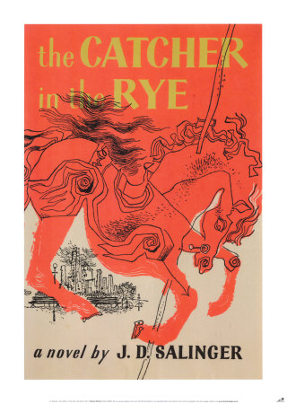***Anna Karenina / War and Peace*, Leo Tolstoy

*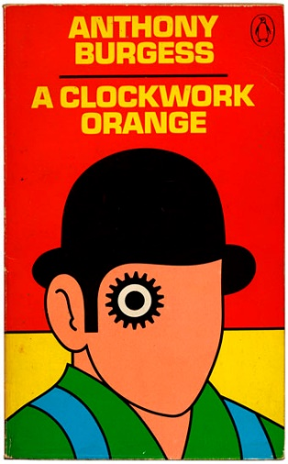Crime and Punishment*, Fyodor Dostoyevsky

*Madame Bovary,* Gustave Flaubert

*The Strange Case of Dr Jekyll and Mr Hyde*,

Robert Louis Stevenson

*Frankenstein*, Mary Shelley

*Dracula*, Bram Stoker

*Therese Raquin*, Emile Zola

**20th CENTURY CLASSICS**

*To Kill a Mockingbird*, Harper Lee

*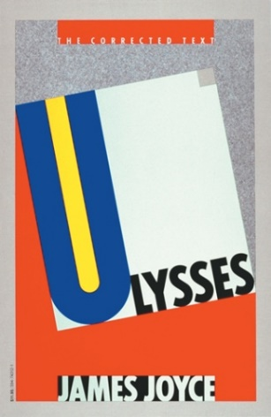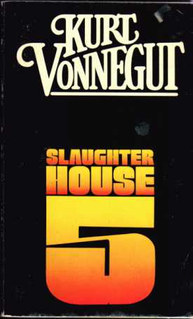Heart of Darkness*, Joseph Conrad

*The Master and Margerita*, Michail Bulgakov

*Nineteen Eighty-Four*, George Orwell

*Sons and Lovers*, D H Lawrence

*Ulysses / A Portrait of the Artist as a Young Man*, James Joyce

*Mrs Dalloway / To the Lighthouse*, Virginia Woolf

*Catch-22*, Joseph Heller

*Rebecca,* Daphne du Maurier

*The Catcher in the Rye*, J.D. Salinger

*One Hundred Years of Solitude / Love in the Time of Cholera*,

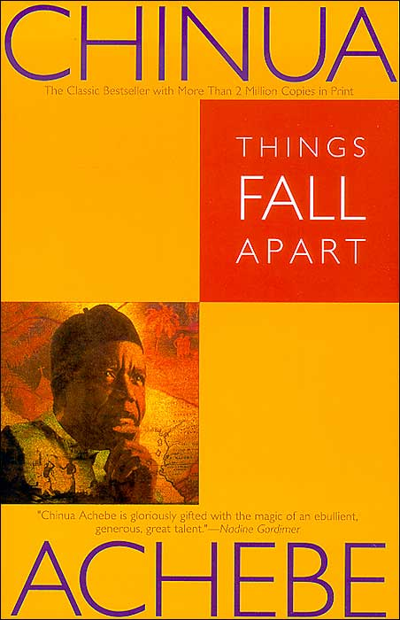Gabriel García Márquez

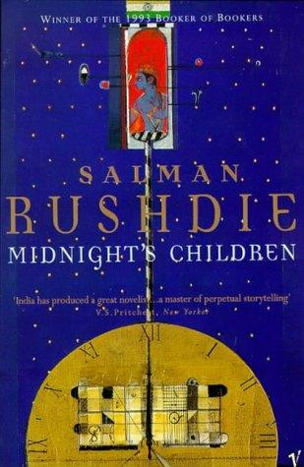*Slaughterhouse 5*, Kurt Vonnegut

*Bonfire of the Vanities*, Tom Wolfe

*Brideshead Revisited*, Evelyn Waugh

*Animal Farm*, George Orwell

*Gormenghast*, Mervyn Peake

*The Awakening*, Kate Chopin

*Ragtime*, E L Doctorow

*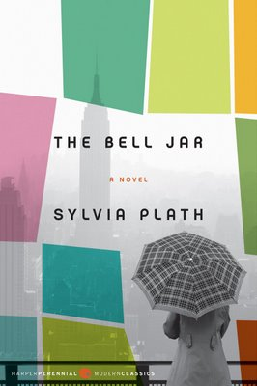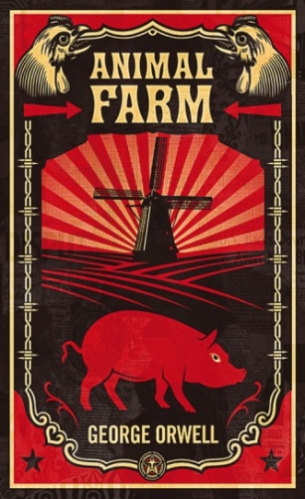Brave New World*, Aldous Huxley

*On The Road*, Jack Kerouac

*Things Fall Apart*, Chinua Achebe  
*I Know Why the Caged Bird Sings*, Maya Angelou

*Oranges Are Not the Only Fruit*, Jeanette Winterson  
*Brighton Rock / The End of the Affair*, Graham Greene

*One Day in the Life of Ivan Denisovitch*, Alexander Solzhenitsyn

*All the Pretty Horses/ The Road*, Cormac McCarthy

*The Handmaid’s Tale*, Margaret Atwood

*A Passage to India / Howard’s End*, E.M. Forster

*A Clockwork Orange*, Anthony Burgess

*The Bell Jar*, Sylvia Plath

*Wide Sargasso Sea / Good Morning Midnight*, Jean Rhys

book cover of 

The Master and the Margarita 

by

Mikhail Bulgakov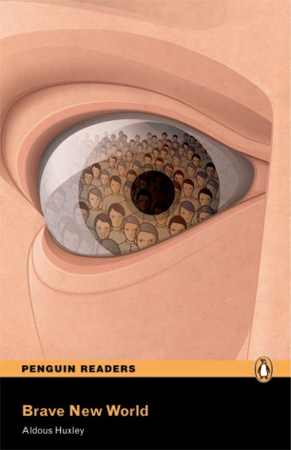*The Color Purple*, Alice Walker

*Beloved*, Toni Morrison

*The Go-Between*, L.P. Hartley

*Cold Comfort Farm*, Stella Gibbons

*The Crying of Lot 49*, Thomas Pynchon

*Metamorphosis,* Franz Kafka

*Midnight's Children*, Salman Rushdie

*book cover of 

Everything Is Illuminated 

by

Jonathan Safran Foer***CONTEMPORARY FICTION &**

**SOME ‘LIGHTER’ READING!**

book cover of 

The Color Purple 

by

Alice Walker*Captain Corelli's Mandolin*, Louis de Bernieres

*The Art of Fielding*, Chad Harbach

*A Suitable Boy*, Vikram Seth

*Memoirs Of A Geisha*, Arthur Golden

*White Noise / Underworld*, Don DeLillo

*Birdsong*, Sebastian Faulks  
*What A Carve Up!*, Jonathan Coe

*American Pastoral*, Philip Roth

*Disgrace*, J.M. Coetzee

*The Unbearable Lightness of Being*, Milan Kundera

*20,000 Streets under the Sky,* Patrick Hamilton

*Perfume*, Patrick Süskind

*The Secret History/ The Goldfinch*, Donna Tartt

*The God of Small Things*, Arundhati Roy

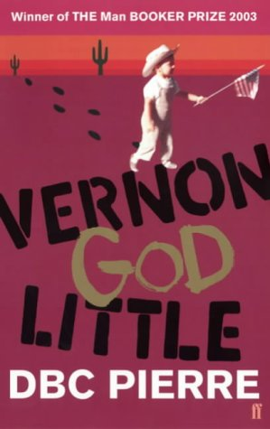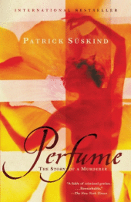*The Godfather*, Mario Puzo

*Regeneration*, Pat Barker

*The Reluctant Fundamentalist*, Mohsin Hamid

*Time’s Arrow*, Martin Amis

*Wolf Hall* / *Bring up the Bodies*, Hilary Mantel

*Possession*, A S Byatt

*Miss Wyoming*, Douglas Coupland

*If on a Winter’s Night a Traveller*, Italo Calvino

*Norwegian Wood / The Wind-Up Bird Chronicles*, Haruki Murakami

*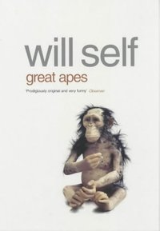The Alchemist*, Paulo Coelho

*A History of the World in 10 ½ Chapters*, Julian Barnes

*The English Patient*, [Michael Ondaatje](http://en.wikipedia.org/wiki/Michael_Ondaatje)

*Remains of the Day / Never Let Me Go*, Kazuo Ishiguro

*If Nobody Speaks of Remarkable Things*, Jon McGregor

*On the Black Hill*, Bruce Chatwin

*Atonement / Enduring Love,* Ian McEwan

*White Teeth / On Beauty*, Zadie Smith

*Great Apes / How the Dead Live*, Will Self

*Middlesex / The Virgin Suicides*, Jeffery Eugenides

*Everything is Illuminated*, Jonathan Safran Foer

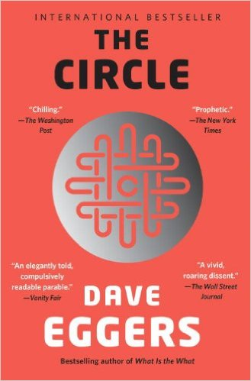*Postcards / Close Range* (short stories), Annie Proulx

*The Poisonwood Bible*, Barbara Kingsolver

*Nights at the Circus*, Angela Carter

*Runaway* (short stories), Alice Munro

*The Magus*, John Fowles

*Hotel World*, Ali Smith

*Pure*, Andrew Miller

*The Unnamed*, Joshua Ferris

*Austerlitz*, W G Sebald

*Cloud Atlas*, David Mitchell

*Fingersmith / The Night Watch*, Sarah Waters

*A Heartbreaking Work of Staggering Genius / The Circle,* Dave Eggers

*We Have Always Lived in the Castle,* Shirley Jackson

*Freedom /The Corrections*, Jonathan Franzen

*The Siege / A Spell of Winter*, Helen Dunmore

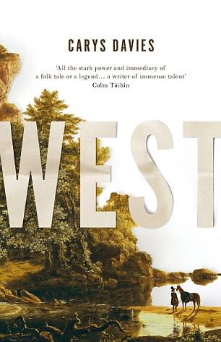*The New York Trilogy / The Book of Illusions*, Paul Auster

*Half of a Yellow Sun / Purple Hibiscus,* Chimamanda Ngozi Adichie

*Suite Francaise,* Irène Némirovsky

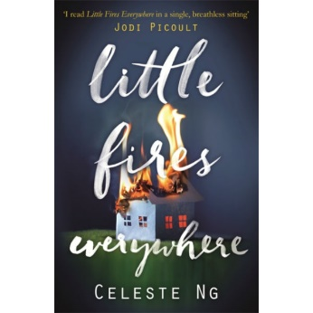*The Diving-bell and the Butterfly,* Dominique Bauby

*The Dig,* Cynan Jones

*West,* Carys Davis

*God’s Own Country,* Ross Raisin

*Little Fires Everywhere*, Celeste Ng

*Billy Lynn’s Long Halftime Walk*, Ben Fountain

*The Goldfinch*, Donna Tartt

*We Are All Completely Beside Ourselves*, Karen Joy Fowler

*Infinite Jest*, David Foster Wallace

*Fight Club*, Chuck Palahniuk

*The Curious Incident of the Dog in the Night Time*, Mark Haddon

*We Need to Talk About Kevin,* Lionel Shriver

[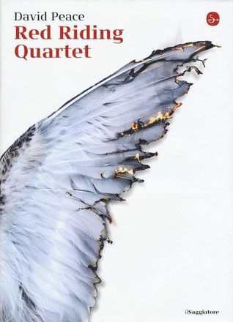](https://www.google.co.uk/url?sa=i&rct=j&q=&esrc=s&source=images&cd=&cad=rja&uact=8&ved=2ahUKEwiN45e8gvHbAhWIwBQKHVE_ACwQjRx6BAgBEAU&url=https://www.goodreads.com/book/show/34382528-red-riding-quartet&psig=AOvVaw3qzUaLp0mVC7CXLOfBij4F&ust=1530091822063107)*Call Me By Your Name,* Andre Aciman

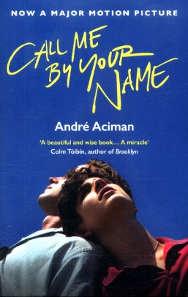*The Lovely Bones,* Alice Sebold

*The Book Thief,* Markus Zukak

*My Life as a Fake,* Peter Carey

*Saturday Night and Sunday Morning*, Alan Sillitoe

*Waterland*, Graham Swift

*Red Riding Quartet,* David Peace

*The Pier Falls* (Short Stories), Mark Haddon

*The Visiting Privilege* (Short Stories), Joy Williams

*A Doll’s Alphabet,*  Camilla Grudova

*An American Marriage,* Tayari Jones

*Lullaby,* Leila Slimani

*Nutshell,* Ian McEwan

*The Underground Railroad,* Colson Whitehead

*A Gentleman in Moscow,* Amor Towles

*Gorsky,* Vesna Goldsworthy

*Milkman,* Anna Burns

*Educated,* Tara Westover

*Normal People,* Sally Rooney

**A SELECTION OF NON-FICTION**

*On the Origin of the Species*, Charles Darwin

*Letters to a Young Poet*, Rainer Maria Rilke

*1599: A Year in the Life of William Shakespeare*, James Shapiro

*Georgiana, Duchess of Devonshire*, Amanda Foreman

*Memoirs of an Infantry Officer*, Siegfried Sassoon

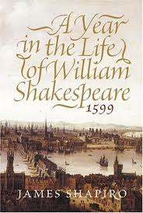*Orientalism*, Edward Said

*Mythologies*, Roland Barthes

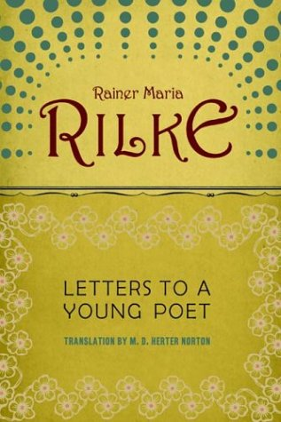*Homage to Catalonia*, George Orwell

*Testament of Youth*, Vera Brittain

*Walden*, Henry David Thoreau

*The Prince*, Niccolo Machiavelli

*The Female Eunuch*, Germaine Greer

*In Cold Blood*, Truman Capote

*Old Glory*, Jonathan Raban

*Midnight in the Garden of Good & Evil*, John Berendt

*Silent Spring*, Rachel Carson

*A Room of One’s Own*, Virginia Woolf

*A Brief History of Time*, Stephen Hawking

*The Wild Places,* Robert Macfarlane

*Into the Wild*, John Krakauer

*The Rest is Noise,* Alex Ross

*Dreams From My Father*, Barack Obama

*No Logo*, Naomi Klein

*The God Delusion*, Richard Dawkins

*Enlightenment Now,* Stephen Pinker

*Walden*, Henry David Thoreau

*The Tipping Point*, Malcolm Gladwell

*This is going to hurt,* Adam Kay

*Bookworm: A Memoir of Childhood Reading,* Lucy Mangan

[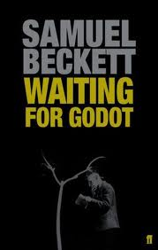](http://images.google.com/imgres?q=waiting+for+godot+book+cover&hl=en&safe=active&bih=870&gbv=2&biw=1280&tbm=isch&tbnid=_h0lHPAdZ2dNeM:&imgrefurl=http://www.faber.co.uk/work/waiting-for-godot/9780571229116/&docid=3fZIMUmUgQBcUM&imgurl=http://www.faber.co.uk/site-media/onix-images/thumbs/1603_jpg_280x450_q85.jpg&w=280&h=440&ei=ge7iT47kIc6XhQfu7ojTAw&zoom=1&iact=hc&vpx=179&vpy=119&dur=1359&hovh=282&hovw=179&tx=105&ty=158&sig=111853967297815978145&page=1&tbnh=165&tbnw=101&start=0&ndsp=26&ved=1t:429,r:0,s:0,i:72)

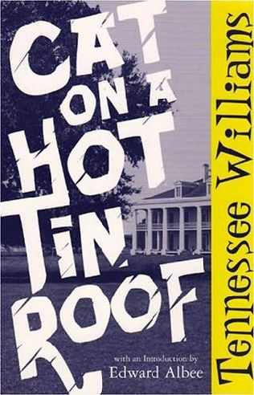**20th CENTURY DRAMA PICKS**

*Waiting for Godot*, Samuel Beckett

*Cat on a Hot Tin Roof*, Tennessee Williams

*All My Sons*, Arthur Miller

*Noises Off*, Michael Frayn

*Arcadia*, Tom Stoppard

*The Madness of King George*, Alan Bennett

*The Caretaker*/*Betrayal,*  Harold Pinter

*Our Country’s Good,* Timberlake Wertenbaker

*The Clearing*, Helen Edmundson

**21st CENTURY DRAMA PICKS**

*DNA*, Denis Kelly

[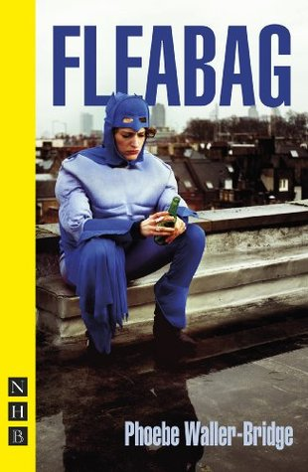](https://www.google.co.uk/url?sa=i&rct=j&q=&esrc=s&source=images&cd=&cad=rja&uact=8&ved=2ahUKEwjOiIiTg_HbAhWB8RQKHYB2COUQjRx6BAgBEAU&url=https://www.goodreads.com/book/show/21185082-fleabag&psig=AOvVaw3HnoljdlJbnkXjjBC9NT1G&ust=1530092025643934)[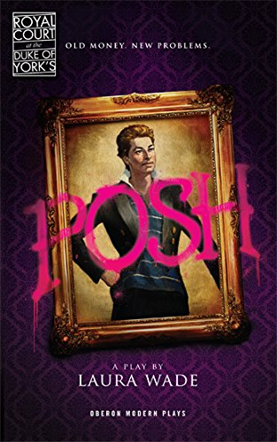](https://www.google.co.uk/url?sa=i&rct=j&q=&esrc=s&source=images&cd=&cad=rja&uact=8&ved=2ahUKEwidgp30g_HbAhXG1hQKHdxWC5AQjRx6BAgBEAU&url=https://www.amazon.co.uk/Posh-Oberon-Modern-Plays-Laura/dp/1840029846&psig=AOvVaw01I5DmrhPaluaURFQ5offL&ust=1530092233001003)*Posh*, Laura Wade

*The Pillowman & Hangmen*, Martin McDonagh

*Dunsinane/The Speculator*, David Grieg

*Mr Burns, a post-electric play*, Ann Washburn

*Love and Information*, Caryl Churchill

*Blackbird*, David Harrower

*Fleabag*, Phoebe Waller-Bridge

*Jerusalem & Mojo*, Jez Butterworth

**DIP INTO SOME POETRY COLLECTIONS…**

*The Secret Life of Poems*, Tom Paulin

*The Rattle Bag*, ed. Heaney & Hughes

*The Penguin book of American Verse*, Geoffrey Moore

*The Bloodaxe Book of 20th Century Poetry*, ed. Edna Longley

*The Oxford Anthology of English Poetry*, Volumes I & II

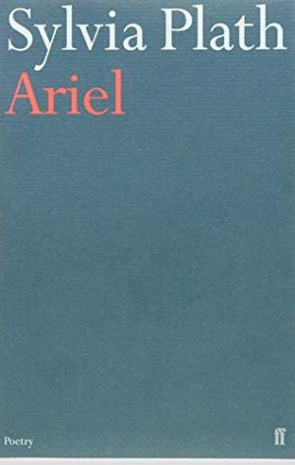*The New Penguin Book of English Verse*, ed. P J Keegan

*Ariel*, Sylvia Plath

*Door into the Dark,* Seamus Heaney

*Loop of Jade*, Sarah Howe

*the sun and her flowers*, Rupi Kaur

*Poetry by Heart* introduced by Andrew Motion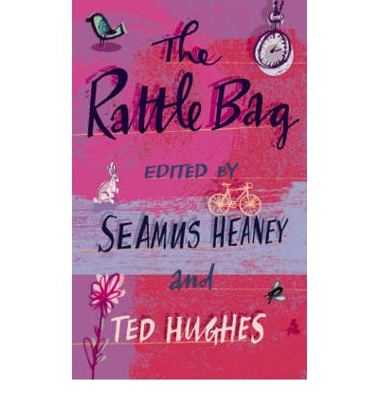 *We British: The Poetry of People* ed. Andrew Marr

*Collected Poems*, Emily Dickinson

*Poems*, Edward Thomas

*Howl*, Allen Ginsberg

*Birthday Letters*, Ted Hughes

*Leaves of Grass*, Walt Whitman

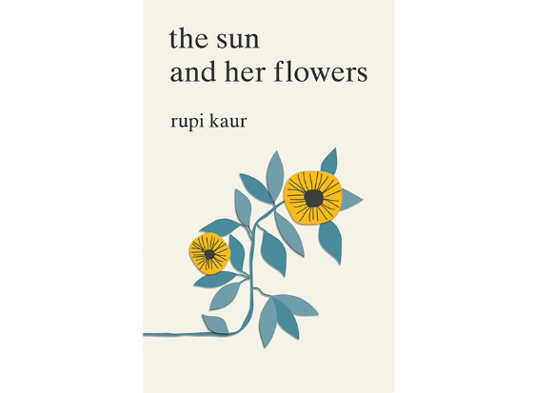*The Sonnets*, William Shakespeare

*Rumi: Selected Poems* (Penguin Classics)

*The Complete English Poems* of John Donne

*American Sonnets for My Past and Future Assassin,* Terrance Hayes

*100 Selected Poems*, e e cummings

**PREPARING FOR COMPONENT 2: AMERICAN FICTION 1880-1940**

***As well as writing on your two set texts (The Great Gatsby by F Scott Fitzgerald & The Sound and the Fury by William Faulkner), there is an unseen element to this paper meaning that it is beneficial to have read widely in preparation for the examination. Over the summer you may wish to read some of the following:***

*Portrait of a Lady* - Henry James(1881)

*Adventures of Huckleberry Finn*, Mark Twain (1884)

*A Hazard of New Fortunes* William Dean Howells, (1890)

*The Yellow Wallpaper* - Charlotte Perkins Gilman (1892)

*Maggie: A Girl of the Streets (1893), The Red Badge of Courage*, Stephen Crane, (1895)

*The Country of the Pointed Firs*, Sarah Orne Jewett (1896)

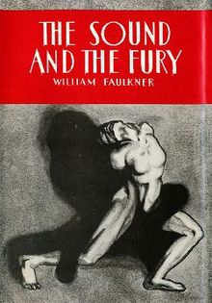*McTeague,* Frank Norris (1899)

**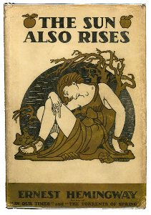***The Awakening*, Kate Chopin (1899)

*Sister Carrie*, Theodore Drieser (1900)

***The Call of the Wild*,** Jack London, (1903)

*The Jungle* Upton Sinclair, (1906)

*Ethan Frome,* Edith Wharton (1911)

*Winesburg, Ohio*, Sherwood Anderson, (1919)

*The Age of Innocence*, Edith Wharton (1920)

*The Great Gatsby*, F. Scott Fitzgerald (1925)

*Gentlemen Prefer Blondes,* Anita Loos (1925)

*Manhattan Transfer* John Dos Passos (1925)

*An American Tragedy*, Theodore Dreiser, (1925)

*Main Street*, Sinclair Lewis, (1925)

*A Moveable Feast/ The Sun also Rises*, Ernest Hemingway (1926)

*The Sound and the Fury*, William Faulkner (1929)

*Look Homeward Angel*, Thomas Wolfe (1929)

*Absalom! Absalom!* William Faulkner, (1936)

*Their Eyes Were Watching God,* Zora Neale Hurston, (1937)

*East of Eden / The Grapes Of Wrath*, John Steinbeck (1939)

*Farewell My Lovely,* Raymond Chandler (1939)

*Native Son,* Richard Wright (1940)

*The Heart is a Lonely Hunter* - Carson McCullers (1940)

***For Whom the Bell Tolls***, Ernest Hemingway (1940)

What have we missed?

As you look over this list, I’m sure that you will feel that there are books

that really must be on it that we haven’t included!

Jot down the titles / authors here and then mention them to your

English teacher for inclusion on next year’s list.